Images: Part 3 | Example
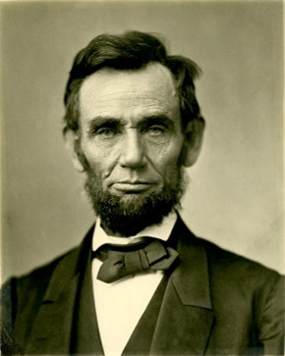
As the sixteenth President of the United States, Abraham Lincoln served as the Commander-in-Chief during the Civil War. He was assassinated five days after the surrender of the Confederate army.

